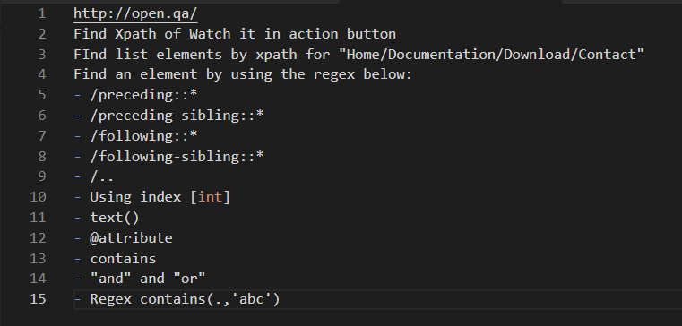

2. Find Xpath of Watch it in action button: //a[@role='button']

3. Find list elements by Xpath for “Home/Documentation/Download/Contact”: //ul[@class='nav nav-justified']

4. Find an element by using the regex below

- text(): //h1[text()='When was the last time you were tested?']

- contains: //h3[contains(text(),'openQA')]

- “and” and “or”: //a[@class='btn btn-primary' or @role='button']

//a[@class='btn btn-primary' and @role='button']

- /preceding::\*: //ul[@class='nav nav-justified']//preceding::h3

- /preceding-sibling::\*: //ul[@class='nav nav-justified']//preceding-sibling::h3

- /following::\*: //ul[@class='nav nav-justified']//following::h2

-/following-sibling::\*: //div[@class='row']//following-sibling::h2

- Using index [int]: //div[@class='col-md-4'][1]

//div[@class=’col-md-4][2]

- /..: /html/body/div[1]/div[1]/h3